**QF600 (Asset Pricing) – Homework 2**

Capital Asset Pricing Model (CAPM)

Market_Portfolio.xlsx contains monthly nominal (net) returns (expressed as percentages) for the market portfolio, over the ten-year period from Jan 2004 through Dec 2013. Assume that the (net) risk-free rate is 0.13% per month.

Market Model

1. Estimate the intercept coefficient (α) and slope coefficient (β) for each of the ten industry portfolio using the market model: regress the monthly *excess* returns for each industry portfolio on the monthly *excess* returns for the market portfolio.
   1. Create a table showing the intercept and slope coefficients for the ten industry portfolios.

Answer:

|  |  |  |
| --- | --- | --- |
| **Industry** | **Intercept (**α) | **Slope (**β) |
| **NoDur** | 0.369443 | 0.652647 |
| **Durbl** | -0.415599 | 1.648536 |
| **Manuf** | 0.159771 | 1.169846 |
| **Enrgy** | 0.501719 | 0.969850 |
| **HiTec** | -0.064020 | 1.132969 |
| **Telcm** | 0.194691 | 0.900729 |
| **Shops** | 0.275492 | 0.826492 |
| **Hlth** | 0.237841 | 0.673036 |
| **Utils** | 0.444585 | 0.538086 |
| **Other** | -0.387135 | 1.207309 |

* 1. Briefly explain (in words, without mathematical equations or formulas) the economic significance and pricing implications of the intercept and slope coefficients.

Answer:

Economic significance of **slope coefficient (*β*)** is to measure the amount of exposure to systematic risk, when investing in an asset or portfolio, that cannot be diversified away because it affects the entire market.

* β > 1 means the asset is more volatile than the market, and vice versa.
* β = 1 means the asset moves in line with the market.
* Negative β means the asset return has negative correlation with market, and vice versa.

For its pricing implication, **slope coefficient (*β*)** indicates how much compensation investors require for the systematic risk associated with holding the asset. If an asset has a high beta (β > 1) investors will expect to get higher return to compensate for its higher risk, and vice versa.

Economic significance of **intercept coefficient (*α*)** represents “pricing error” (relative to CAPM) for individual assets or “passive” portfolios. The alpha coefficient (intercept) shows how much the excess asset returns vary from the required return (after adjusting for market volatilities and fluctuations).

For its pricing implication, the **intercept coefficient (*α*)** should be zero if CAPM is correct. Meaning all assets are correctly priced according to their risk.

* A positive alpha (α) means that the asset has outperformed the expected return based on its systematic risk. This means that the asset is undervalued and demand is likely to increase which will push the price higher, driving the alpha closer to zero
* While a negative alpha (α) means underperformance. This means that the asset is overvalued and demand is likely to decrease which will lower the price, driving alpha closer to zero.

Security Market Line (SML)

1. Calculate the mean monthly return for each of the ten industry portfolios, as well as the market portfolio.

Answer:

|  |  |
| --- | --- |
| **Industry** | **Mean Return (%)** |
| NoDur | 0.902833 |
| Durbl | 0.733333 |
| Manuf | 1.012833 |
| Enrgy | 1.231167 |
| HiTec | 0.76625 |
| Telcm | 0.881417 |
| Shops | 0.916333 |
| Hlth | 0.783833 |
| Utils | 0.907167 |
| Other | 0.489083 |
| Market | 0.748083 |

1. Regress the mean monthly returns of the ten industry portfolios and the market portfolio on the corresponding β's. This will give you the intercept and slope coefficients for the SML. (Note that the results may be very different from what you would expect!)
   1. Use the estimated intercept and slope coefficients for the SML to plot the SML in the range of β from zero to two on the horizontal axis.

Answer:

SML slope coefficient = -0.18546745836573272

SML y-intercept = 1.0327683682657056

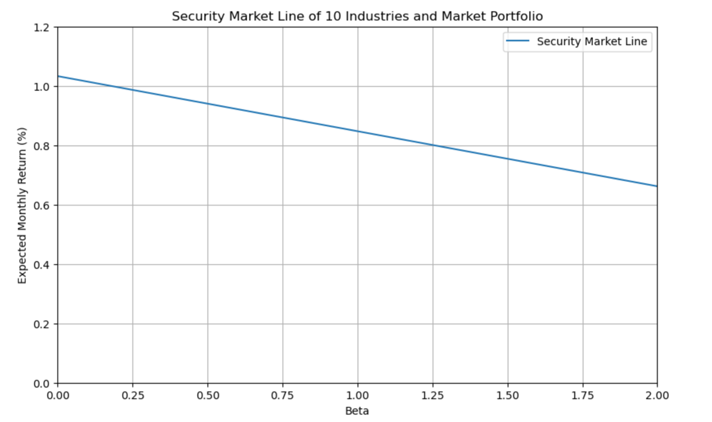

* 1. Also plot the positions of the ten industry portfolios and the market portfolio. (You are NOT required to label the individual portfolios.)

Answer:

* 1. Briefly explain the economic significance and pricing implications of the SML.

Answer:

The economic significance of SML is that it is a graphical representation of CAPM pricing formula that applies to every asset portfolio. The SML slope represents the ratio of risk premium to beta, or Treynor ratio (which calculates excess return over systematic risk). Hence, all risky assets and portfolios must have the same Treynor ratio, in equilibrium.

The pricing implication of SML is that:

* Asset that lies above the SML are underpriced, which will offer higher returns for their risk level, so investors will buy, which drives up the price and will eventually lower the expected return.
* Asset that lies below the SML are overpriced, so investors will sell assets, causing the price to fall and raise expected return.
* Price will rise or fall until the asset is back to SML, reflecting their fair price given the level of risk, according to CAPM.